UID LAB EXPERIMENT 5
RAGHURAM K

ARBOR APPLICATION UI DESIGN PROTOTYPE
- Home
The Home module acts as the primary dashboard of the application. It provides users with a quick snapshot of essential information such as weather conditions and location-based insights. It also includes shortcut access to core features like crop guidance, crop management, and disease planning. This module is designed to minimize user effort by centralizing frequently used functionalities in one place.

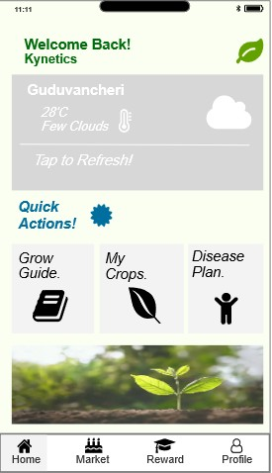

- Market
The Market module enables users to explore agricultural products and pricing information. It allows farmers to view current market trends, compare prices, and make informed selling or purchasing decisions. This module supports better financial planning and market awareness.

- Reward
The Reward module is designed to encourage user engagement and sustainable practices. Users can earn rewards or points based on their activities within the application, such as maintaining crops, following recommendations, or completing tasks. These rewards can be tracked and potentially redeemed within the platform.

- Profile
The Profile module manages user-specific information and settings. It includes personal details, preferences, and account-related configurations. This module ensures that user data is organized and accessible, enabling a personalized experience across the application.
- Visual Content Section
  - Displays an image of a growing plant.
  - Serves as a thematic and motivational visual element.
Design Intent:
To reinforce the agricultural theme and improve visual appeal without adding functional complexity.

- Bottom Navigation Bar (Overview Only)
(Detailed design to be documented separately as mentioned)
  - Contains four primary navigation items:
○ Home
○ Market
○ Reward
○ Profile
  - Icons are used alongside labels for intuitive navigation.
Design Intent:
To provide persistent, easy access to major modules of the application.

- Layout and Design Principles
  - Color Scheme:
Light green and white tones to reflect sustainability and nature.
  - Card-Based Layout:
Modular design ensures scalability and readability.
  - Icon Usage:
Enhances usability and reduces text dependency.
  - Spacing and Alignment:
Maintains a clean and uncluttered interface.

- User Interaction Flow
  - User lands on the dashboard after login.
  - Views current weather and location details.
  - Uses “Quick Actions” to navigate to core features.
  - Uses bottom navigation for broader app exploration.

- Conclusion
This dashboard is designed as a central control panel for users, combining environmental awareness with quick feature access. The structure ensures minimal cognitive load while supporting efficient interaction, making it suitable for both novice and experienced users in an agricultural context.

